WEST LONDON WASTE AUTHORITY
Report of the Finance Director | 2 December 2022
2023/24 Budget

SUMMARY
This report sets out the 2023/24 budget proposal for consultation with boroughs and the key points are as follows:
- The Authority is budgeting to pay boroughs PPP income (i.e. electricity) totalling £6.3 million in July 2023.
- Costs and levies growth is contained to 1.8% (£2.6 million) in context of inflation running in excess of 10%.
- A programme of work totalling £2.8m over 3 years (£1.1. million in 2023/24) is to be funded from the Authority’s share of PPP income and will deliver carbon and financial savings directly to boroughs
RECOMMENDATION(S)
The Authority is asked to:-
- Note the 2023/24 budget for consultation
- Note the programme of work to be met from the PPP income
- Note the Pay As You Throw (PAYT) rates in section 15 and the PAYT levy made up of two components totalling of £53.1 million
- Note the Fixed Cost Levy (FCL) of £14.0 million in section 16
- Note the recommended trade and construction prices in section 17 and delegated authority to the Finance Director to change these in year should the need arise
- Note the anticipated PPP income and payment to boroughs of approximately £1.0 million per borough in July 2023 of their share of PPP income.
- Note the new proposed capital budgets in section 18
- Note the target level of reserves of £10.3 million to act as a buffer for managing risks (including the risk around the level of PPP income), in section 19
- Note the Medium and Long Term Financial Plan in section 20
- Introduction

  - The Authority is required to set an annual budget including levies and charges. This report sets out the 2023-24 draft budget which will be subject to consultation with constituent boroughs.
  - Following consultation, the final budget will be reported to the January Authority meeting for approval. The PAYT and FCL charges will then be levied.
  - The budget incorporates tonnage forecasts received from boroughs and the spending plans received from Authority managers which include delivery of business plan objectives. The draft budget has been scrutinised and adjusted following a budget challenge session with the Chair, Vice Chair and Chief Officers on 9 November.
  - The report has also been shared with borough Environment Directors and borough Finance Directors and meetings are ongoing as part of the consultation process.
- Executive Summary
  - This year amidst greater economic uncertainty and financial challenge, the 2023/24 budget proposal takes a step further in the Authority’s approach to providing boroughs with greater stability and better predictability (a key theme identified in the Finance Strategy).
  - The 2023/24 budget anticipates PPP income and proposes to pay boroughs £6.3 million in July 2023 apportioned using the final approved council tax base (i.e. approx. £1 million each).
  - Previously, sharing income in this way has only taken place after income has been received. Budgeting for the payment of £6.3 million will therefore require the Authority to manage the risk of lower than anticipated income (e.g. due to low electricity prices, actual impact of windfall taxes) by using its reserves.
  - Most of the Authority’s spending relates to borough activity levels which are met/serviced through contracts. So the key drivers of costs and therefore levies are the borough’s own forecast activity levels and the contractual inflation.
  - For 2023/24 the rise in overall costs and therefore levies has been contained at 1.8% or £2.6 million. This is in context of inflationary forecasts of 10.6% (HM Treasury) for price rises next April. This year’s high inflationary impact has been partly offset by lower budgeted borough activity levels.
  - The key long term mitigation of spend and therefore levies is managing the wasteflows. These are largely within the control of boroughs so the budget also identifies 3 new key programmes of work to be met from the Authority’s share of PPP income already received. £1.1 million is budgeted to be invested in this work in 2023/24.
  - The programmes of work will identify interventions where boroughs will see the benefits in their own budgets - essentially spend (Authority) to save (boroughs) programmes. For example the existing programme of removing food waste from residual waste streams so more residents use the food waste services already there. These programmes of work will be developed and agreed with stakeholders in due course.
  - The potential value of programmes of similar work across West London using an analysis from 2019 as the basis, shows the change required and the potential savings on offer of millions of pounds per year across all constituent boroughs. This can be found in appendix 2 which identifies the areas of work along with key borough priorities and feedback overlaid for each area. The savings are presently an indicative figure. A more detailed and up to date analysis will be undertaken over coming months as we develop the joint waste strategy. Never-the-less, it is clear that the sums/opportunity is significant, as is the challenge.
  - The table over the page sets out the 2023/24 budget and the movement from the 2022/23 budget. The latest 2022/23 forecast is also included to provide context and illustrate the current level of activity. The spend lines have also been split out to separate the spend from business as usual activities and those from the programme of work funded by PPP income, providing better transparency.
 | 2022-23 budget  £ 000’s | 2022-23 forecast £ 000’s | 2023-24 budget  £ 000’s | Changes in budgets £ 000’s
Business As Usual Costs
WTD - Waste Transport and Disposal | 49,558 | 48,059 | 51,531 | 1,973
Funding of HRRC project | 1,200 | 1,200 | 0 | (1,200)
Depreciation | 9,809 | 10,469 | 10,375 | 566
Financing Cost | 5,105 | 5,105 | 4,971 | (134)
Premises | 2,672 | 2,516 | 2,603 | (69)
Employees | 2,516 | 2,660 | 2,617 | 101
Supplies and Services | 1,198 | 1,098 | 1,187 | (11)
MRF Service Costs | 2,148 | 2,027 | 2,256 | 108
Revenue Funding of Debt | 962 | 962 | 984 | 22
Concession Accounting Adjustments | (4,473) | (4,473) | (4,570) | (97)
BAU costs | 70,695 | 69,623 | 71,954 | 1,259
Programme of work funded by PPP income
Depreciation | 0 | 0 | 107 | 107
Premises | 0 | 0 | 45 | 45
Employees | 132 | 98 | 308 | 176
Supplies and Services | 0 | 0 | 660 | 660
Programme costs | 132 | 98 | 1,120 | 998
Total costs | 70,827 | 69,721 | 73,074 | 2,247
Income
Levies | 64,551 | 63,538 | 67,116 | 2,565
MRF service income | 2,148 | 2,027 | 2,256 | 108
Other Income | 2,128 | 3,092 | 2,582 | 454
PPP one off benefit | 2,000 | 9,450 | 0 | (2,000)
Programme costs funded by PPP income | 0 | 0 | 1,120 | 1,120
Total income | 70,827 | 78,107 | 73,074 | 2,247
Total (surplus)/deficit | 0 | (8,386) | 0 | 0
PPP income disbursed to boroughs | 0 | 7,100 | 6,300 | 6,300
  - Otherwise the budget headings are per our usual format for regular budget monitoring reports and accounting categories. The most notable movements relate to the growth in waste transport and disposal costs and levies, the removal of one off items from the previous year, the inclusion of PPP income payable to boroughs and the funding of 3 programmes of work.
  - Note that the MRF activities have a neutral effect with costs being passed through to Ealing for the services provided.
  - Plans for the coming year and an explanation of budget items follows.
- Programme of work funded by PPP income
3.1 The Finance Strategy approved in September identified that two thirds of PPP income would be passed through to boroughs and one third of PPP income would be set aside for Authority Strategic projects.
3.2 On this basis for the Authority’s share of PPP income, 3 programmes of work have been identified:
- Digital Twin – to decarbonise collection services and find immediate cost savings for boroughs
- Social Value and Reuse – to decarbonise HRRC services and create social value
- Communications – To better inform residents of complex recycling challenges and inform boroughs of recycling opportunities
Brief summaries follow. The programmes will be developed with borough colleagues and reported to stakeholders for approval in due course.
3.3 Digital Twin - The objective is to create a digital twin of on the ground waste and recycling services and achieve rapid decarbonisation and cost savings for Boroughs through data led efficiency savings. The programme will be evaluated over 3 years, cost £855,000 which will be fully covered by in Borough savings during the period and will identify future annual costs and savings in the next steps.
Year 1 and 2 Deliverables:
- A digital version of the kerbside services, communal services, street cleansing routes and trade services for all 6 west London boroughs.
- Integration of data eg tonnages, carbon, demographics for these services into our reporting systems in Power BI and the self-service platform so real time data is available to boroughs.
- ANPR integration at HRRC sites.
- Collection of new data to enable better understanding of capture and participation in services.
- Route optimisation of existing services across Harrow and Hounslow.
- Creation of user-friendly data sets that can be used to model all the data requirements for the proposed EPR system and to underpin the procurement of new contracts to recycle and transport a wider range of materials.
- Development of links with planning data and permits for waste sites to better understand capacity and impact of new developments on service provision.
3.4 Social Value and Reuse - The objective is to increase separation of materials, innovate new handling and storage methods to retain the value of the item not just the material it is made from. The aim is to deliver immediate changes to existing infrastructure and measure the social and financial value of circular economy projects. We will test our ability to invest directly into borough sites not owned by WLWA and measure the co-benefits of efficiencies. The programme will test service resilience to change
The Authority have created this opportunity with a combination of several projects at Abbey Road and working closely with operatives at Townmead Road. They have invested in solar panels, created the fixing factory, built a circular economy relationship with Petit Miracles, extracted bicycles, children’s toys and NHS equipment from waste and recirculated it creating social value. Most Boroughs have identified similar circular economy projects This programme starts to pull the whole system together to scale up and create additional value with a hub and spoke model
3.5 Communications - The objective is to test citizen knowledge and attitudes to recycling services. It will create content to provide more and better information on some of the more complex issues and test knowledge and attitudes again at the end. Recycling, reuse, social value and waste data will also be used to evaluate the work. Food waste recycling is the service that most citizens don’t use. Persuading every household to recycle food waste will reduce waste, reduce cost, increase recycling and contribute to global and UK decarbonisation. It will result in cost savings for citizens, Boroughs and WLWA. Cost savings for WLWA and Boroughs means more money available to invest in other recycling services. We want to normalise food waste recycling and ban food waste from the bin. Similarly this programme of work will also look at plastics, textiles, electricals / batteries, reuse / social value and dry mixed recycling.
3.6 The above provides an outline of the 3 programmes of work. The programme spending totalling £2.8 million is to be met from the WLWA share of PPP income already received and will run over three years delivering both financial and carbon benefits directly to boroughs.
- Waste Transport & Disposal (WTD)

  - The WTD budget accounts for the majority of the entire WLWA budget and makes up 72% of the spending. Strategically, this is where most of the significant saving opportunities can be found.

  - The 2023/24 WTD budget is £51.5 million, an increase of £1.9 million.
  - The residual waste budget is the key driver and represents 80% of the WTD costs (or 58% of all Authority costs – hence the strategic significance). For 2023/24 this is based on boroughs’ forecasts of residual waste which are 3.7% lower than the 2022/23 budget and reflecting the current level of activity.
  - Looking at the complete picture, the 2023/24 budgeted tonnage is made up of the following materials:
Material | 2022/23 Budget Tonnes | 2023/24 Budget Tonnes | Change
Residual | 433,711 | 417,757 | (15,954)
Green | 53,610 | 45,799 | (7,811)
Wood | 17,694 | 16,121 | (1,573)
Kitchen | 39,300 | 32,616 | (6,684)
Other | 11,849 | 4,745 | (7,104)
Budgeted tonnages | 556,164 | 517,038 | (39,126)
  - No significant service changes were identified by boroughs. Borough forecast volumes are lower than last year’s budget setting exercise but in overall terms show a small growth on current activity levels.
  - To calculate the budgeted spend, RPIX of 10.6% (a mid-range forecast from HM treasury) has been applied to contractor prices where there is a contractual indexation requirement. Published forecasts including HM Treasury range from 7.8% to 12.6% with Septembers RPIX standing at 12.6%.
  - It is worth noting that within the main PPP contract this impact is partly mitigated by the pricing mechanism which dampens the overall effect of inflation – a very effective feature of the contract. This is highlighted in the sensitivity analysis in section 20.
  - Where other contracts are due for procurement, procuring managers have used best available market information to estimate rates for the coming year.
- Depreciation

  - The depreciation budgets for 2023/24 of £10.5 million is £0.7 million higher than in 2022/23. This reflects property asset valuations undertaken for the 2021/22 accounts and agreed with auditors for the accounts and capital additions.
  - The largest element of depreciation relates to the SERC (Severnside Energy Recovery Centre) and totals £8.8 million. It should be noted that for depreciation calculations, the SERC has to be separated out into its main components and each key component has to be depreciated over its own expected life.
  - Depreciation for the remaining assets have been calculated using valuations agreed with auditors and subsequent change in the asset registers (i.e. additions and disposals).
- Financing

  - The financing costs reflect the interest paid on loans. These have reduced from £5.1 million in 2022/23 to £5.0 million for 2023/24 primarily as a result of the payment profile of repayment loans. With repayment loans a fixed sum is paid every year comprising of both interest and principal repayment. The interest element will continue to fall over coming years, conversely the principal repayment will rise.
  - The largest component of financing costs relates to borrowing from boroughs for the construction of the SERC and totals £4.5 million. The loans are at arm’s length and from a borrowing perspective the boroughs are like any other lender with the loan agreements specifying the relationship with the Authority and including a rate of interest of 7.604%.
  - The interest on loans for the purchase of transfer station freeholds makes up the balance of £0.5 million and represents a PWLB loan at 2.24%.
- Premises
  - The overall premises budgets for 2023/24 of £2.6 million are slightly lower than 2022/23 reflecting the challenge to Authority’s managers to identify savings.
  - The largest component of the premises costs are business rates which account for £2.3 million of this budget of which SERC rates make up £1.3 million and transfer stations £0.8 million.
- Employees
  - The 2023/24 employee budgets of £2.9 million is £0.3 million higher than the 2022/23 level. This growth relates principally to programme resources (3 FTE) and wage inflation (3%) which is partly offset by savings from a reduction in the business as usual establishment.
  - The 2023/24 establishment of 42.7 full time equivalent (FTE) posts is an increase of 2.6 from the previous year. Putting this into context the Authority employed 42 FTE in 2014/15 and over many years FTE numbers have subsequently stayed close to 40. The size of the staffing establishment numbers remains small and stable whilst providing the resource to drive forwards business plan objectives and undertake the increasing volume, variety and complexity of work.
  - A notional breakdown of the establishment by area of activity and whether business as usual (BAU) or programme work is provided below:
BAU Activity | 2022/23 | 2023/24 | Change
Contracts/Operations | 19.0 | 19.0 | 0
Corporate Services | 9.1 | 9.7 | 0.6
Projects | 9.0 | 8.0 | (1.0)
Total | 37.1 | 36.7 | (0.4)

Programme Activity | 2022/23 | 2023/24 | Change
Contracts/Operations | 1.0 | 1.0 | 0
Corporate Services | 1.0 | 2.0 | 1.0
Projects | 1.0 | 3.0 | 2.0
Total | 3.0 | 6.0 | 3.0

Total FTE | 40.1 | 42.7 | 2.6
- Supplies & Services
  - The 2023/24 overall budgets for Supplies & Services is £1.8 million up by £0.6 million from 2022/23. With a focus on savings managers have slightly reduced business as usual spending. The growth relates to programme spending which is to be met from PPP income.
  - A wide variety of spends make up this total including £0.7 million for the programme of work in section 3.
  - Other notable items include spending for professional services, external audit, insurances and borough services (e.g. committee services, treasury etc.).
  - Budgets for some minor costs have been stripped out.
- Revenue Funding of Debt
  - The loan which financed the purchase of the transfer station sites is a typical repayment loan. It is made up of two components – an element for the interest on the loan (see Financing Costs) and an element repaying the loan principal.
  - The Revenue Funding of Debt is the element repaying the sites loan and totals £1.0 million for 2023/24. This is marginally higher (£20,000) than 2022/23 reflecting that within a typical repayment loan, the amount of principal repaid increases over time and amount of interest falls.
  - It is worth providing the following brief recap of the revenue funding of debt which was detailed in Authority papers recommending the site purchase a number of years ago.
  - It is a requirement for public bodies to ultimately fund the cost of assets through levies and taxes. For the Authority this is achieved through a combination of the depreciation charge and revenue funding of debt.
  - Typically the acquisition of assets result in an annual depreciation charge. This annual expenditure is recovered through the levy mechanism and therefore the levies over the life of the asset fund its purchase.
  - However, the acquisition of the sites freehold is essentially a purchase of land. For land, accounting rules do not allow a depreciation charge. This means that in order to fund the purchase through levies a different (but comparable to depreciation) annual charge is made – the revenue funding of debt.
- Concession Accounting Adjustments
  - Essentially under a PPP arrangement a contractor pays for the construction of an asset and then recovers its investment over a long period through its operational charges to the local authority (i.e. its price per tonne).
  - There are very specific and detailed accounting requirements that govern this type of arrangement. This is because the underlying nature of this transaction is that the local authority essentially owns the asset for a period of time and the contractor is essentially a lender financing the construction of the asset.
  - The key feature of the accounting is the calculation of a concession accounting adjustment to separate out the disposal and financing costs, followed by stripping out from expenditure a notional sum for the repayment of any underlying borrowing by the contractor.
  - The concession accounting adjustments over the term of the contract were agreed with the auditors EY. For 2023/24 they total £4.6 million, compared to £4.5 million in 2022/23. This accounting adjustment reduces overall costs and levies.
- Growth and Savings
  - The majority of Authority spending is committed under long term contracts (e.g. PPP) or agreements (e.g. loans) or governed by accounting requirements (e.g. depreciation). This leaves less opportunity for savings.
  - However, as part of the budget setting process at an operational level, a variety of measures (including a managers’ challenge session with the Senior Leadership Team) have ensured savings across areas where managers are able to exercise some control.
  - The tables below identify the growth and savings which are included within the 2023/24 draft budget. The tables separate out real growth and savings from other movements reflecting longer term decisions.
  - Summary table:
 | £ 000’s
Net budgeted costs/levies 2021/22 | 64,551
Growth | 5,094
Savings | (2,673)
Other movements | 144
Budgeted costs/levies 2022/23 | 67,116
  - Growth table:
Area | Explanation | Growth  £ 000’s
Waste Transport and Disposal | Increased contract costs resulting from inflation for residual waste (£3,116,000), haulage (£225,000), increase in wood (£356,000), increase in rubble volumes (£264,000) and a range of movements in other materials spends (£151,000) | 4,112
Premises | New automatic number plate recognition for the smart cities work (£45,000) | 45
Employees | 2.6 FTE increase in establishment (£151,000), salary inflation 3% (89,000) and other minor movements (£37,000) | 277
Supplies and Services | Digital twin, reuse and communications advice and services (£660,000) | 660
 |  | 5,094
  - Savings table:
Area | Explanation | Saving  £ 000’s
Waste Transport and Disposal | Reduction in residual volumes (£1,612,000), reduction in mattress volumes (£257,000) and better pricing achieved from procurement of green waste (£270,000) | (2,139)
Premises | Reduction in SERC related premises costs (£69,000) | (69)
Supplies and Services | Stripping out of unspent minor budgets (£11,000) | (11)
Other Income | Growth in trade income (£400,000), sale of recyclables (£40,000) and other minor improvements (£14,000) | (454)
 |  | (2,673)
  - Other movements table:
Area | Explanation | Increase / (Decrease) £ 000’s
Depreciation | Reflecting property valuations agreed with auditors for the last accounts | 673
Financing Costs | Reflecting reducing interest in repayment loans for SERC with boroughs | (134)
Revenue Funding of Debt | Reflecting rising repayment of principal in repayment loan for sites with PWLB | 22
Concession Accounting Adjustment | Reflecting adjustments agreed with auditors for the last accounts | (97)
PPP Income / HRRC funding | 2022/23 one off item superseded by Finance Strategy methodology for sharing PPP income | 800
Programme work funded by PPP income | Funding of strategic projects per Finance Strategy | (1,120)
 |  | 144
- PAYT / FCL split
13.1 PAYT costs relate to waste that boroughs collect and deliver to transfer stations and FCL costs are those which relate to waste from HRRC sites and the Authority’s running expenses.
13.2 Both also include an element for the recovery of SERC financing costs, depreciation, rates and concession accounting adjustments.
13.3 The breakdown of the budget between PAYT and FCL activities is as follows:
PAYT (disposal cost) | 2022/23  £000’s | 2023/24  £000’s | Change  £000’s
Waste Transport and Disposal | 41,894 | 43,986 | 2,092
PAYT Levy (disposal) | (41,894) | (43,986) | (2,092)
Total | 0 | 0 | 0

PAYT (SERC cost) | 2022/23  £000’s | 2023/24  £000’s | Change  £000’s
Depreciation (SERC) | 7,204 | 7,934 | 730
Financing Costs (SERC) | 3,976 | 4,070 | 94
Premises (SERC) | 1,194 | 1,210 | 16
Concession Accounting Adjustment (SERC) | (3,838) | (4,114) | (276)
PAYT Levy (SERC) | (8,536) | (9,100) | (564)
Total | 0 | 0 | 0

FCL | 2022/23  £000’s | 2023/24  £000’s | Change  £000’s
Waste Transport and Disposal | 7,664 | 7,545 | (119)
Employees | 2,648 | 2,925 | 277
Premises | 1,478 | 1,438 | (40)
Supplies and Services | 1,198 | 1,847 | 649
Depreciation | 2,605 | 2,548 | (57)
Financing | 1,129 | 901 | (228)
Revenue funding of Debt | 962 | 984 | 22
Concession Accounting Adjustment | (635) | (456) | 178
Non Levy Income | (2,128) | (2,582) | (454)
PPP one off benefit / HRRC funding | (800) | 0 | 800
PPP Income funding programme of work | 0 | (1,120) | (1,120)
FCL Levy | (14,122) | (14,030) | 92
Total | 0 | 0 | 0

13.4 Note that above there are two elements of the PAYT and one element of FCL.
- Levy Setting
  - The breakdown of the Authority’s costs into the three components identified in section 13 are the basis of the charging to boroughs. Each element is apportioned to boroughs in different ways.
- PAYT (disposal) – Rates (£/tonne) for different materials which reflect the average prices paid to contractors, charged to boroughs initially on the basis of budgeted tonnes but then reconciled and adjusted (with rebate/charge) at the end of each quarter to reflect the actual tonnages.
- PAYT (SERC) – this is the apportioned recharge of SERC costs (depreciation, financing etc) . The cost is initially apportioned and charged on the basis of budgeted tonnes then at the end of every quarter recalculated using the actual tonnage with any adjustment being rebated/charged to the borough.
- FCL (fixed) – this is the recharge for all other costs (i.e. HRRC, overheads, an element of SERC costs etc) apportioned on the basis of boroughs tax base from their final approved CTB1 returns.
Details of these follow in the next two sections.
- PAYT Levy Income
  - As identified above the PAYT is made up of two components and therefore the PAYT levy is too. Combined the PAYT levy will total £53.1 million (from the tables above £44.0 million plus £9.1 million).
  - The table below shows the proposed disposal rates for waste in 2023/24.
Material (Disposal) | 2022/23 £ per tonne | 2023/24 £ per tonne
Residual | 101.09 | 109.76
Gully | 57.31 | 67.31
Food | 9.98 | 11.61
Green | 40.00 | 40.94
Wood | 43.54 | 67.67
Rubble | 45.08 | 32.63
Soil | 46.35 | 32.63
Mattresses (per mattress) | 4.40 | 5.46
  - In addition to this, the Authority manages non-household waste from HRRC sites and incurs transport costs. On a similar basis the average transport charges are provided below.
Material (Transport) | 2022/23 £ per tonne | 2023/24 £ per tonne
Residual (collected) | 11.26 | 12.22
Other recyclables (collected) | 15.34 | 18.63
  - These rates represent the average cost (or estimated cost for contracts due to be procured) to the Authority for the disposal and transport of materials. They are the PAYT rates payable by boroughs in order to recover costs.
  - These rates are applied to the 2023/24 tonnage forecasts from boroughs and result in a monthly charge to them. Each quarter end a reconciliation exercise will take place to adjust for the actual amount of waste that each borough delivers, so boroughs only pay for the volume of waste actually disposed.
  - Using tonnage forecasts from boroughs, the PAYT charges for 2023/24 are as follows:
Borough | 2022/23 PAYT disposal charge £000’s | 2023/24 PAYT disposal charge £000’s | Increase / (decrease)  £000’s
Brent | 7,790 | 8,008 | 218
Ealing | 8,159 | 8,920 | 761
Harrow | 6,130 | 6,486 | 356
Hillingdon | 8,169 | 8,583 | 414
Hounslow | 6,799 | 7,048 | 249
Richmond | 4,847 | 4,941 | 94
Total | 41,894 | 43,986 | 2,092
  - The movement in the disposal costs of borough collected waste is reflected here.
  - It is worth repeating that should borough waste volumes be higher or lower than forecast, then each quarter boroughs will be charged or refunded a sum to ensure they pay only for what is actually delivered.
  - The second, PAYT (SERC) component relates to the £9.1 million SERC cost, equivalent to £24.43 per tonne (2022/23: £23.14). This will initially be apportioned and levied on the basis of 2023/24 budgeted residual waste tonnages excluding gully waste. A quarterly exercise will then adjust this sum to reflect the actual residual tonnages delivered that quarter with a reimbursement or additional charge. The initial apportioned annual charge is summarised below.
Borough | 2022/23 PAYT SERC charge £000’s | 2023/24 PAYT SERC charge £000’s | Growth  £000’s
Brent | 1,646 | 1,710 | 64
Ealing | 1,738 | 1,929 | 191
Harrow | 1,239 | 1,342 | 103
Hillingdon | 1,530 | 1,678 | 148
Hounslow | 1,382 | 1,445 | 63
Richmond | 1,001 | 996 | (5)
Total | 8,536 | 9,100 | 564
  - The movement in the proportion of SERC cost (depreciation, financing etc) relating to borough collections is reflected here.
16. FCL Income
  - The FCL charge primarily relates to the costs of managing the treatment and disposal of household waste delivered to HRRC sites. It also includes the Authority’s administration and nets off other income. These costs are apportioned to the boroughs.
  - The apportionment calculation initially uses last year’s provisional Council Tax base figures provided by the boroughs. However, when charging, the FCL costs will be apportioned using the final borough approved Council Tax base. Borough Council Tax base figures may not all be published in time for the January Authority meeting and therefore the FCL charges will be finalised shortly afterwards.
  - On this basis the draft FCL (fixed) charge is as follows:
Borough | 2022/23 FCL charge £000’s | Estimated 2022/23 Council Tax base | 2023/24  FCL  charge £000’s | Change £000’s
Brent | 2,432 | 99,868 | 2,381 | (51)
Ealing | 2,589 | 118,649 | 2,829 | 240
Harrow | 2,205 | 90,597 | 2,160 | (45)
Hillingdon | 2,503 | 103,840 | 2,476 | (27)
Hounslow | 2,174 | 86,769 | 2,069 | (105)
Richmond | 2,220 | 88,703 | 2,115 | (105)
Total | 14,123 | 588,426 | 14,030 | 93
  - The movement in all other costs including disposal and haulage of HRRC waste,
  - The FCL (fixed) sum will not change over the course of the year. The Authority bears any loss or surplus resulting from overspend or underspend.
17. Other Income

  - The 2023/24 budget is £2.5 million, which is a £0.4 million improvement on 2022/23 and reflect activity at slightly less than current levels to allow for some loss in revenue due to the economic circumstances.
  - The majority of the income is from trade waste (£1.9 million). The proposed main trade and construction charges per tonne at Abbey Road are unchanged to remain competitive and are provided below.

Type of waste | 2022/23 £ | 2023/24 £
Trade waste residual and wood | 160.00 for account customers and £165.00 for others | 160.00 for account customers and £165.00 for others
Trade waste recycling | 80.00 | 80.00
Asbestos (Households only) | 272.00 | 272.00
Mattresses (per mattress) | 15.00 | 15.00
Bulky items | 218.00 | 218.00
Gas bottles from commercial sources | 5.00 | 5.00
Fire extinguishers from commercial sources | 5.00 | 5.00
Fridges from commercial sources | 40.00 | 40.00
  - Changes and further charges may be introduced during the year in response to market conditions and where appropriate in consultation with LB Brent. It is recommended that delegated authority be given to the Finance Director to change charges in year should the need arise.
  - Other income includes an agency fee which passes on the costs of running the Abbey Road HRRC to the local borough. This is being maintained at current levels.
  - In July 2023 the PPP contractor will pay the Authority its share of income in relation to the PPP contract, principally electricity generation income.
  - At this stage, estimation of the sum due is inherent with market risks (electricity prices are volatile), political risks (detailed working of the windfall tax) and economic risks (the impact of industrial action on the power production). Never-the-less, it is likely that the Authority will see significant income (£9.4 million) if we assume ongoing electricity production and prices at the current levels and the introduction of a windfall tax.
  - On this basis the estimated distribution to boroughs on receipt of funds from the contractor will be in the region of £1 million each. This represents the two thirds pass through to boroughs of the estimated PPP income (in accordance with the Finance Strategy) which will be apportioned to each borough using the final approved council tax base.
  - The Authority is mindful of the challenging local authority finances so to help boroughs to budget for this income with greater certainty, the Authority is committing (through this budget) to the distribution and will utilise its reserves to manage the risks (section 19) of non-receipt on PPP income or receipts being lower than estimated. Any additional PPP income received will also be shared in accordance with the Finance Strategy.
18. Capital

  - The new capital budget requirements for 2023/24 are listed below:
- Victoria Road food and bulking shed £800,000
- West Drayton heating system improvements and window replacement (£150,000) to improve energy efficiency
- Abbey Road improvements (£122,000) including weighbridge scales, electric man gates, replacement netting, heating improvements, improvements to toilet and shower facilities.
- Upgrades to waste data management system (£80,000) and finance system (£20,000)
  - It is worth noting the following existing capital budgets. These are balances remaining on budgets for capital works still in progress/to be commenced, which were previously approved by the Authority and will be rolled forward until completion or eliminated if not required.
- Abbey Road improvements (£477,000) including CCTV fire & ANPR systems, mobile plant for bulky waste, shuttering/re-concrete of contamination bay, mechanical pallet mover, new main gate, electric van charging point, LED lighting and water service improvements
- £500,000 DMR and food recycling infrastructure at Abbey Road – increasing options for material contracts and improving recycling and diversion rates from residual treatment. This essentially upgrades and future proofs Abbey Road for EPR
- Circular economy hub solutions including shipping containers (£90,000)
- Victoria Road bulking facilities (£1,000,000) representing 50% of the capital budget to complete work to increase bulking and sorting capacity to enhance and localise material value and reduce whole system bulking costs.
- New weighbridge software (£20,000)
- Textile/Nappy collection facilities (£10,000)
- Resurfacing work at Transport Avenue and Victoria Road (£290,000)
- Reserves
  - Reserves represent an organisations net worth. They provide a buffer for an organisation to manage risks, for example the fluctuations in the level of activity or costs – these variances in costs lead to surpluses and deficits being absorbed within reserves. On this basis, the Authority’s approach to reserves has been to build up sufficient reserves to act as a buffer against risk.
  - The added benefit of reserves is that they can be used to stabilise pricing by removing the need for “in year” price reviews. For boroughs and indeed the Authority, this pricing stability / predictability facilitates much better planning and budgetary control.
  - For 2023/24 the proposal for reserves is cautious given the economic climate and continuing uncertainties resulting from the pandemic.
  - Considering reserves in overall terms, identifying known material risks facing an Authority provides a useful basis for determining a suitable level of reserves for managing risk. The specific risks and potential costs and likelihood that could be associated with them are as follows:
Risk Description | Mitigations | Likelihood | Financial Risk (£000’s) | Reserves to set aside (high 100, medium 75%, low 50%)
The budget is based on assumptions of indexation/ inflation, particularly in relation to contracts. There is a risk of higher costs due to higher than anticipated indexation/inflation, particularly the impact of utility prices and driver shortages on prices. | Use of reputable forecasts e.g. HM Treasury | High | £2,500 (representing approx. 5% of WTD costs) | £2,500
Increased regulation of emissions from energy from waste facilities requiring one off installation of equipment | Contract terms | High | £2,000 | £2,000
Borough FCL tonnages are higher than budgeted resulting in an under-recovery of HRRC disposal costs through the FCL charge which is fixed | Using data and working closely with borough colleagues to try and forecast tonnages accurately | Medium | £1,600 (based on residual FCL tonnages at 20% in excess of budgeted levels) | £1,200
Industrial action creating site and wasteflow disruption including | Contract terms, contractor business continuity plans and contingency arrangements, insurances | Medium | £950  representing 1 day per month disruption for 12 months effecting 650 tonnes of recycling per day needing to be sent to EfW @£110 disposal and £12 haulage | £710
The PPP income to pay to boroughs does not materialise e.g. electricity prices don’t remain high and windfall tax | Contract terms | Low | £6,300 | £3,150
Costs arising from the complex PPP contract as a result of terms that are unclear or ambiguous in relation to the day to day operation and running of services. | Team and professional advisors with experience and knowledge of detailed contract terms | Low | £1,000 (based on experience of contractual issues) | £500
With a large number of competitors ready to receive trade waste, there is a risk that price competition could lead to a reduction in planned trade and construction income despite more competitive pricing | Ongoing monitoring of trade income and maintaining competitive pricing position in market place | Low | £500 (representing 20% of trade income | £250
Target level for reserves to manage risks |  |  |  | £10,310
  - The target level of reserves for 2023/24 is £10.3 million and relates to the immediate risks relevant to 2023/24 year’s activities. This compares to £9.2 million of risks in 2022/23. The main changes relate to the removal of longer term risks, updating of the PPP income risk and the inclusion of mitigations for emissions risk.
  - Ultimately, the level of reserves is a judgment based on the nature of risk facing an organisation and its risk appetite. On the basis of the risks identified above and appreciating that there are unknown risks which could materialise and that nothing is being set aside for longer term risks, the proposed level represents a prudent and not overly cautious target for reserves for 2023/24 activities.
  - The forecast reserve position for the year ending 31 March 2024 is:
 | Reserves to manage risks £000’s | PPP Income £000s | Total Reserves £000s
Total Reserves 31 March 2022 | 64,446 | 3,550 | 67,996
Less Revaluation Reserve (artificial gain/not realisable) | (52,732) | 0 | (52,732)
Reserves 31 March 2022 | 11,714 | 3,550 | 15,264
Forecast surplus 2022/23 | 8,386 | 0 | 8,386
PPP income share for boroughs | (6,300) | 0 | (6,300)
PPP income share for WLWA | (3,150) | 3,150 | 0
Reserves 31 March 2023 | 10,650 | 6,700 | 17,350
PPP income committed for WLWA programme of work | 0 | (2,800) | (2,800)
Forecast surplus 2023/24 | 0 | 0 | 0
Forecast position for 31 March 2024 | 10,650 | 3,900 | 14,550
  - The above table shows the expected PPP income of £9.4 million being shared in accordance with the Finance Strategy. £6.3 million will be paid to boroughs following receipt of funds from the contractor (July 2023) and £3.1 million retained by the Authority.
  - Provided that no risks materialise the closing reserves balance to manage risks of £10.6 million is close to the target level of £10.3 million and there are no excess reserves for distribution to boroughs.
  - In comparison other London waste Authorities hold reserves ranging from £31 million to £73 million. This reflects the Authority’s strong history of passing on excess reserves to boroughs.
  - The above table also shows the Authority’s retained PPP income following the income sharing with boroughs in October 2022 and the anticipated receipt in July 2023. This totalled £6.7 million and as outlined in section 3, three programmes of work have been identified and £1.1 million will be utilised to deliver some of this work in 2023/24. A further £1.7 million will be utilised in the subsequent two years to reflect the total commitment of £2.8 million of funding to be met from PPP income.
- Medium and Long Term Plan
  - The plan has been updated to incorporate the proposed budget and uses long term base case assumptions of 0.5% for the annual growth in residual tonnages to reflect population increases, and 3.0% for long term inflation long term inflation (2.0% was used last year) which is higher than the long term HM Treasury target of 2.0%.
  - The key outputs can be found in Appendix 1 and this shows a healthy financial position. The assumptions are then flexed to identify the key factors effecting the Authority’s finances. This identifies changes in the residual waste tonnages as the key strategic factor determining the growth in costs and levies. Inflation has less impact (although still significant) as a cost driver as a result of the dampening effect of the PPP contract pricing mechanism.
  - The key messages from the plan are consistent with last year and are positive.
- The volume of residual waste is the key driver of spend/levies, so its reduction should be a key area of strategic focus e.g. removing food waste from the residual waste stream being an important opportunity
- The effect of inflation is dampened by the PPP contract
- The Authority will be debt free at the end of the plan and will maintain healthy cash balances to manage any liquidity risk
- Financial Implications
  - These are included in the report.
  - It is a statutory requirement for the Authority to set a balanced budget (Local Government Finance Act 1992) and to set the levy for constituent boroughs by 15 February (Joint Waste Disposal Authorities (Levies) Regulations 2006).
- Legal Implications
23.1 The are no legal implications of this report
Contact Officers | Jay Patel, Finance Director 01895 54 55 11  jaypatel@westlondonwaste.gov.uk  Ian O’Donnell, Treasurer  ianodonnell@westlondonwaste.gov.uk  Emma Beal, Managing Director 01895 54 55 15  emmabeal@westlondonwaste.gov.uk

Appendix 1
Outputs
Using the proposed budget and base assumptions, the medium and long term financial model then gives us some outputs, for example, how our costs (and consequently levies to boroughs) change over time, or how our loan and cash balance changes over time. The main outputs are provided below and illustrate that affecting residual waste tonnages is the key.

Tonnage – The chart below illustrates the impact of the base assumption of 0.5% annual growth in residual tonnage to reflect population growth. Over the life of the plan, the residual tonnage rises from 413,171 to 452,577 tonnes.

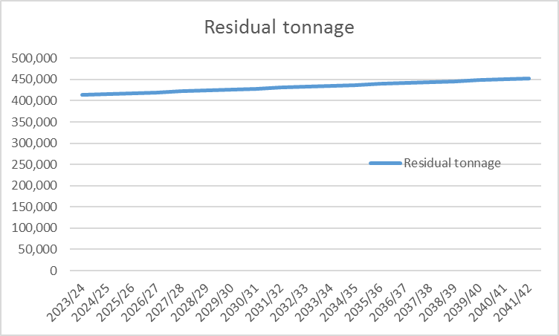

Overall expenditure – This equates to the total levies charged to boroughs and the chart below has been split to show the PAYT and FCL as well as the total. The chart illustrates the growth in overall expenditure and levies over time.

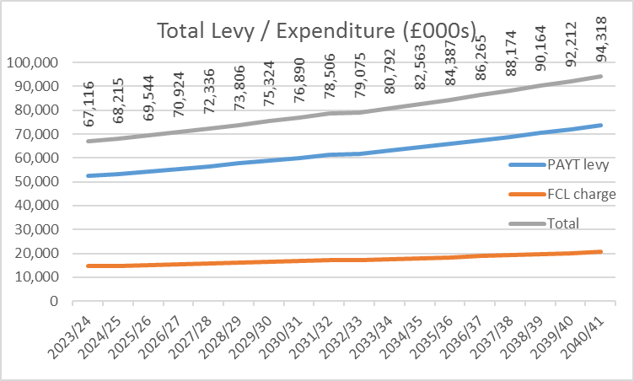

This chart above illustrates an average annual growth of 1.7% over the long-term which is significantly lower than the 3.5% underlying long term growth assumptions in the plan, principally inflation RPIX (3.0%) and annual growth in tonnages (0.5%) to reflect population rises.

This growth is contained as a result of the way the PPP contract is structured. This is because the first 235,000 tonnes is essentially protected from 90% of the effect of inflation. This significantly dampens the effect of inflation on residual waste costs over the whole life of the contract.

The dampened growth in costs and levies is further illustrated in the medium term in the chart below.
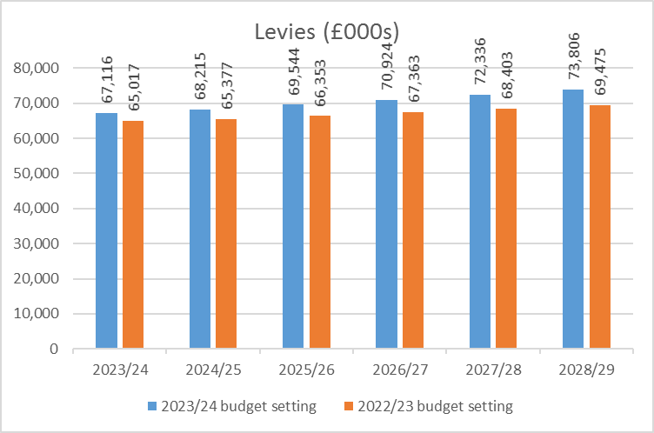

The table above shows an average growth in levies of 1.9% per year over the next 5 years. The change in the chart reflects the high starting point due to 2023/24 inflation (10.6%) and the higher longer term projection of inflation of 3% (compared to 2% last year). In this context, containing the long term growth demonstrates the strength of the Authority’s finances. Boroughs may want to consider using this as an estimate of the increase in the WLWA levies within their medium term financial plans.

Debt / long-term liabilities and cash – The following chart illustrates the movement in the debt / long-term liabilities as they are paid / settled. The repayments commence at a low level and progress at increasingly larger sums, resulting in the debt/long term liability curve. The effect of the financing is reflected in the cash balances which build up in early years and fall in later years.

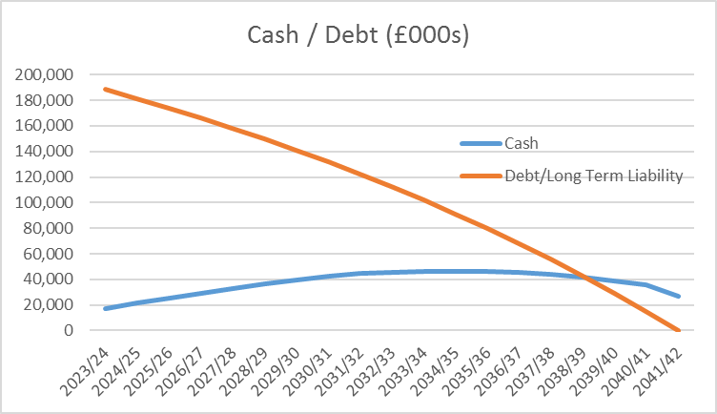

At the end of the plan, the Authority will be debt free.
Sensitivity Analysis
The two tables below illustrate that the impact of the change in residual waste volumes is the key driver of costs/levies with changes in inflation having a much smaller impact. This is because the effect of inflation is considerably dampened by the long term PPP contract.
Residual tonnages.
Residual waste growth assumption | Average rise in costs / levies over 5 years
-5% | -3.4%
-2% | -0.7%
-1.5% | -0.2%
-1% | 0.3%
-0.5% | 0.7%
0% | 1.2%
0.5% base | 1.7%
1% | 2.1%
1.5% | 2.6%
2% | 3.1%
5% | 5.9%
Similarly for residual contract inflation (RPIX).
Residual contract inflation RPIX | Average rise in costs / levies over 5 years
1% | 0.7%
2% | 1.2%
3% base | 1.7%
4% | 2.1%
5% | 2.6%
6% | 3.1%

